5th grade

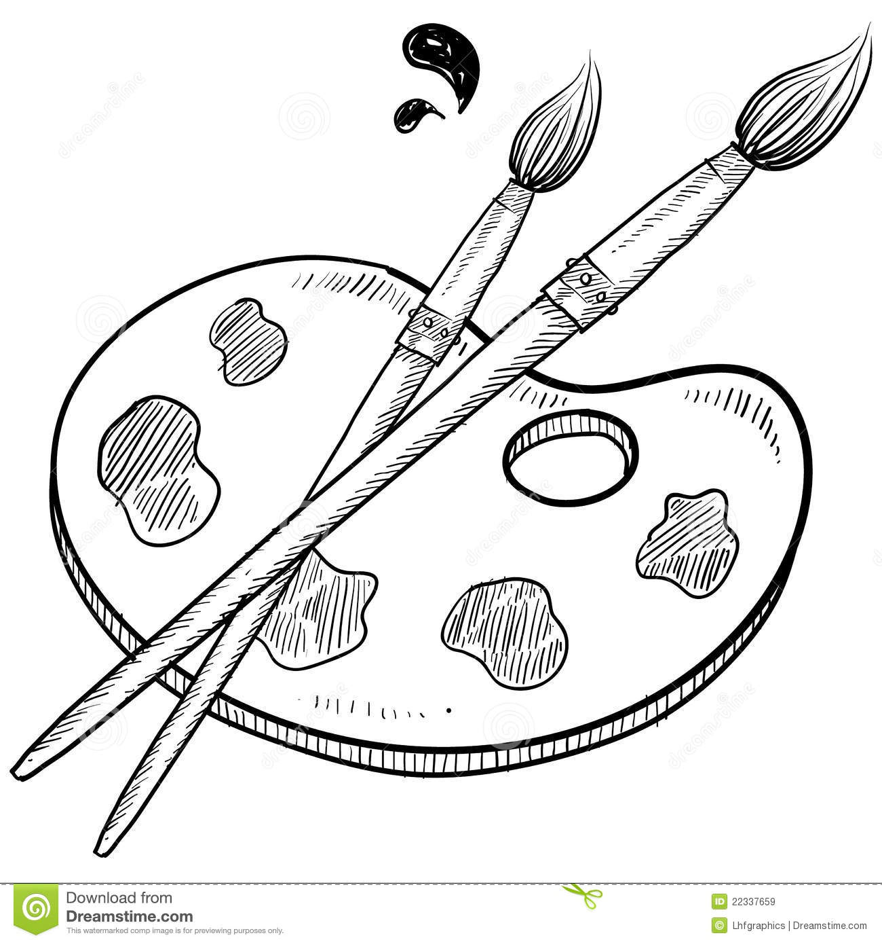

Welcome to

Poquessing Middle School

{2017-2018 Class Syllabus}

**ART**

⚫⚫⚫⚫⚫⚫⚫⚫⚫⚫⚫⚫⚫⚫⚫⚫⚫⚫ ⚫⚫⚫⚫⚫⚫⚫⚫⚫⚫⚫⚫⚫⚫⚫⚫⚫⚫ ⚫⚫⚫⚫⚫⚫⚫⚫⚫⚫⚫⚫⚫⚫⚫⚫⚫⚫ ⚫⚫⚫⚫⚫⚫⚫⚫⚫⚫⚫⚫⚫⚫⚫⚫⚫⚫⚫⚫⚫⚫

|  |
| --- |
| Mrs. Loizos ⚫ Room 109 ⚫ dloizos@neshaminy.org ⚫ 215.809.6210 |

**Supplies Required Daily:**

*You will receive a letter grade for Art*:

A (excellent), B (above average), C (average), D (below average), F (failing)

IPR’s and Marking Period grades are given for Art.

Grading is specific to each assignment, so each project will have a grading breakdown in small steps.

**Everything we do is graded.** Even sketches are worth points. Complete everything and turn it in!

**Points are deducted for incomplete work.** Students who miss work due to absences, lessons, etc. are expected to make up their work either during class time, WIN period, or at home. Do not wait until the end of the marking period to make-up work.

**Grading:**

* Pocket Folder. ***Color*** ____________

(Stays in the Art Room, sent home at the end.)

* A pencil & eraser
* Old t-shirt (Optional)

**How to be Successful in Art Class:**

**Classroom Expectations:**

* Bring your pencil, your agenda, and an open mind to class everyday
* Follow the Art Room rules (“How to Be Successful in Art Class”)
* Complete all assignments/projects
* Conduct yourself respectfully

**Chromebooks in Art**

* Please bring your Chromebook with you to every Art class.
* We will use Chromebooks occasionally to enhance our work (look up reference photos, etc.) – but remember, our main focus is to *work in the studio*!

We will be manipulating and experimenting with many different materials. As long as you follow directions, pay attention and work hard, you will do fine.

Don’t be afraid to get messy! ☺

**Enjoy your time here!**

Art Projects, Assignments, & Sketches are graded using the following standards:

* Following Directions
* Neatness/Craftsmanship
* Proper Technique/Use of Materials
* Creativity/Originality
* Effort and Involvement during class time